Meiosis and Fertilization – Understanding How Genes Are Inherited

Introduction

1a. What is a gene?

1b. Describe the processes that ensure that each cell in your body has a complete set of chromosomes with all your genes.

2. What do you already know about meiosis and fertilization?

3. This flowchart summarizes how a child inherits one copy of each gene from each parent. During fertilization, a sperm unites with an egg to produce a zygote, which is a fertilized egg. Fill in the blanks in the flowchart.

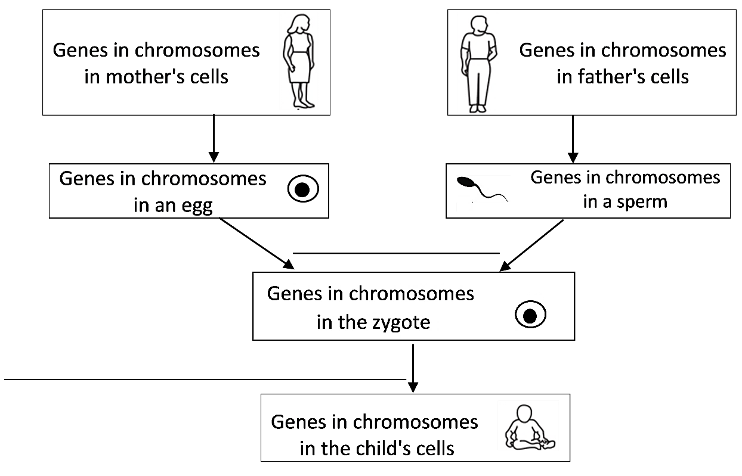

4. The zygote has all the chromosomes with all the genes that were in the egg and sperm. What problem would occur if eggs and sperm were produced by mitosis?

To understand the biological solution to the problem that would occur if eggs and sperm were made by mitosis, we need to think about pairs of homologous chromosomes.

5. What is a pair of homologous chromosomes?

- A diploid cell has pairs of homologous chromosomes. Almost all the cells in your body are diploid.  - A haploid cell has only one chromosome from each pair of homologous chromosomes. Eggs and sperm are haploid cells. | 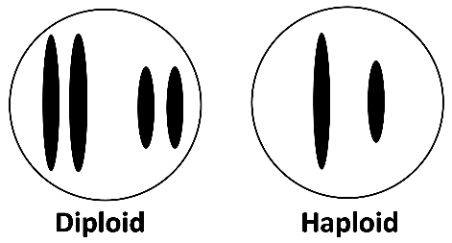
6a. Circle each pair of homologous chromosomes in the above figure.

6b. A haploid cell has ____________ as many chromosomes as a diploid cell.
(half / twice)

The type of cell division that produces haploid eggs and sperm from diploid cells is called meiosis. As a result of meiosis, each egg or sperm receives one chromosome from each pair of homologous chromosomes in the parent.

7a. Fill in each blank in this flowchart.  7b. Circle a pair of homologous chromosomes in the zygote.  7c. Write d next to the diploid cells and h next to the haploid cells.  7d. Match each item in the first list with the best match from the second list.  Diploid cell → diploid cells ___  Diploid cell → haploid cells ___  Haploid cells → diploid cell ___  a. Fertilization b. Meiosis c. Mitosis  This completed flowchart summarizes how a child inherits one copy of each gene from each parent. | 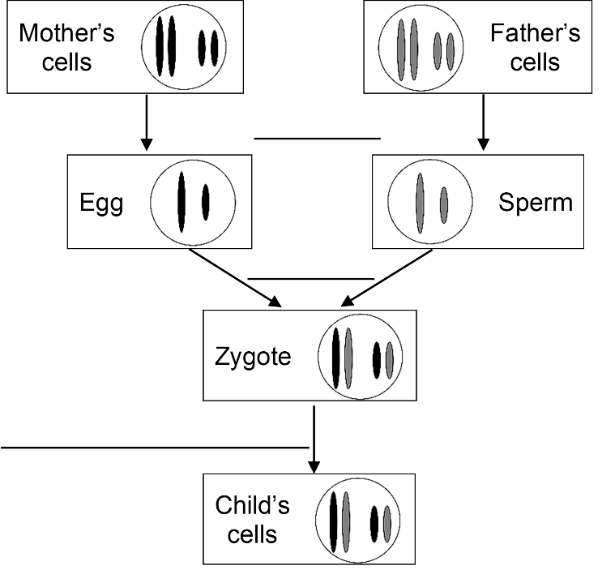

8. Use what you have learned to explain how each cell in a child inherits one copy of each gene from his/her mother and another copy of each gene from his/her father. (A complete answer will include these terms: meiosis, haploid, egg, sperm, fertilizes or fertilization, zygote, diploid, pair of homologous chromosomes, gene, mitosis.)

How Meiosis Makes Haploid Eggs and Sperm

Eggs and sperm are called gametes. The figure below shows how a diploid cell divides into haploid gametes. First, the DNA in the diploid cell is replicated, and then two cell divisions produce four haploid gametes. The two cell divisions are called meiosis I and meiosis II.

9. Each paragraph below describes a step in meiosis. Draw a line connecting each paragraph to a matching arrow in the figure.  At the beginning of meiosis I, the two homologous chromosomes are lined up next to each other. The two copies of the DNA in each chromosome condense into sister chromatids.  During the meiosis I cell division, the two homologous chromosomes are separated into two daughter cells. These daughter cells are haploid since each daughter cell has only one chromosome from each pair of homologous chromosomes.  During meiosis II, the sister chromatids of each chromosome are separated. Meiosis II produces haploid gametes.  10a. The A and a alleles are only labeled on some of the chromatids or chromosomes. Use your understanding of DNA replication and meiosis to label the A or a alleles on the other chromatids and chromosomes. | 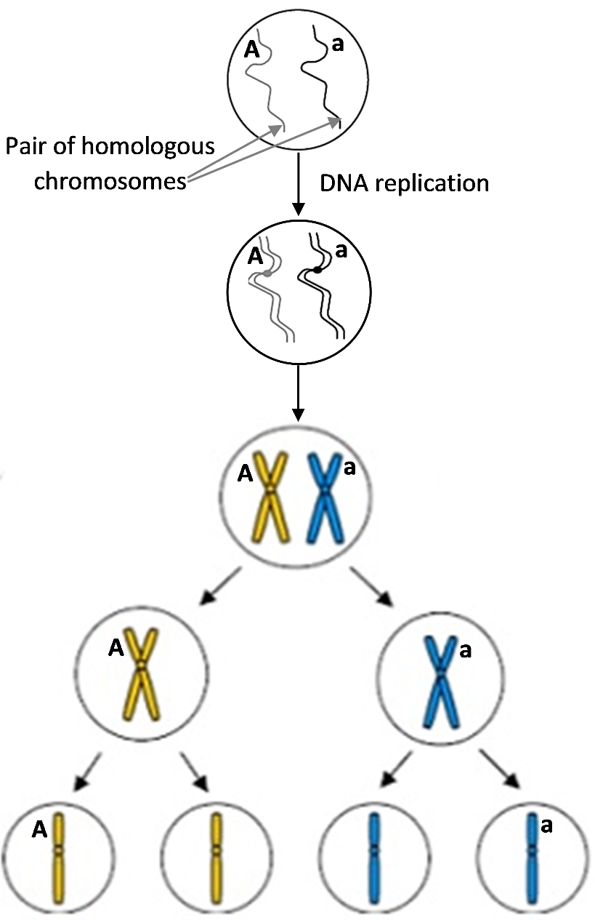

10b. For the labeled gene, there are ___ different types of haploid gametes.
(1/2/3)

11. To produce haploid gametes, DNA is replicated ___ time(s), followed by ___ cell division(s).
(0/1/2) (0/1/2)

12. To describe the characteristics of meiosis I, meiosis II, and mitosis, put a check for each characteristic that applies.

 | Meiosis I | Meiosis II | Mitosis
Separates pairs of homologous chromosomes
Separates sister chromatids
Produces genetically identical diploid cells
Produces genetically diverse haploid cells

Next, you will model meiosis using a pair of model chromosomes with the alleles shown here. Notice that the alleles for albinism (a) and sickle-cell hemoglobin (h) are on the same chromosome. There are more than 1000 additional genes on this chromosome. | 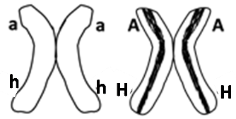

- Use your pair of model chromosomes to model each step of meiosis. Use your arms as spindle fibers to move the chromosomes, and use erasable marker, chalk or string to represent the cell membranes at each stage.
13a. Show the results of your modeling in this flowchart. Draw and label the chromosomes in each cell that is produced by meiosis I and by meiosis II.  13b. Which two combinations of alleles do you observe in the gametes?  __ah__ _____  Next, you will learn about two other processes during meiosis that contribute to the enormous genetic diversity of different gametes produced by the same person. | 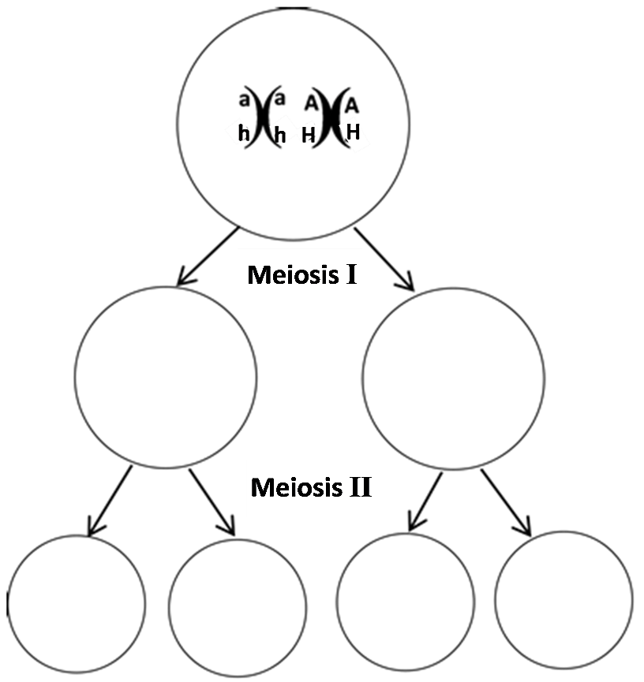

At the beginning of meiosis, pairs of homologous chromosomes line up next to each other. This figure shows one chromosome that began meiosis with the A and H alleles and the homologous chromosome with the a and h alleles. Crossing over occurred when the two homologous chromosomes exchanged parts of their chromatids.  14. Label the alleles for these genes on each chromatid of the chromosomes in the bottom row, after crossing over.  15. After meiosis separates the homologous chromosomes and the sister chromatids, the gametes will have four different combinations of the alleles for these two genes. The combinations of alleles in the different gametes will be:  _AH_ _______ _______ _______ . | 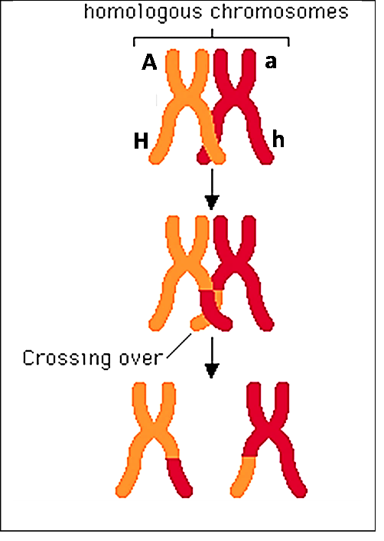

Next, you will model meiosis using the two pairs of homologous chromosomes shown in the chart below. Notice that the two pairs of homologous chromosomes can line up in two different ways at the beginning of meiosis I. This is called independent assortment, since each pair of homologous chromosomes lines up independently of how the other pair of homologous chromosomes lined up.

- Use your two pairs of homologous chromosomes to model meiosis I and meiosis II for each possible way of lining up the model chromosomes at the beginning of meiosis I.

16. Complete this chart. Draw the missing chromosomes and label the alleles on each chromatid and chromosome.
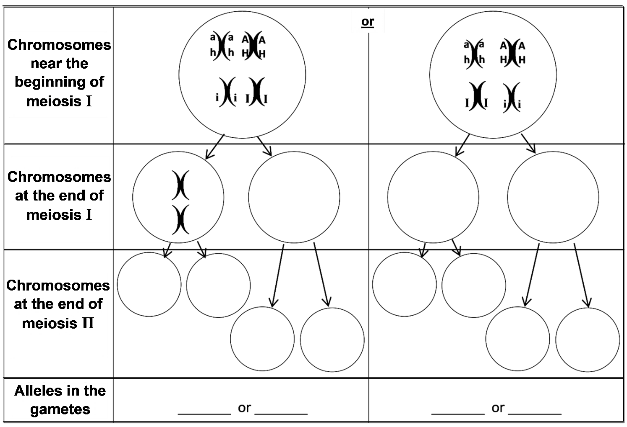

17. As a result of your modeling, you saw that independent assortment resulted in gametes with four different combinations of these alleles. What additional process could produce gametes with these four additional combinations of alleles – aHi, aHI, AhI and Ahi?

You have shown that crossing over and independent assortment during meiosis can produce gametes with 2³ = 8 different combinations of the alleles for these three genes. Each human body cell has thousands of genes in 23 pairs of homologous chromosomes. Independent assortment of 23 pairs of homologous chromosomes can produce 2²³ = ~8.4 million different combinations of chromosomes in different gametes produced by the same person! Crossing over results in an even greater number of different combinations of alleles in these gametes.
Genes are inherited via meiosis and fertilization.

To learn how meiosis and fertilization determine the genetic makeup of a child, you will analyze inheritance for two parents who both have the Aa genotype. This flowchart shows how these parents could have a child with the Aa genotype.

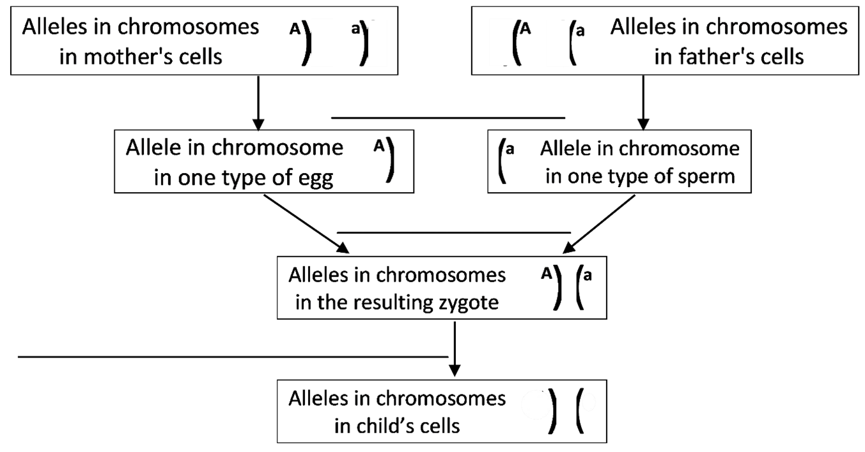
18a. Fill in the blanks in this flowchart.

18b. Label the alleles in the child’s cells. Explain how you know what these alleles are.

18c. Do you think that this is the only possible outcome of meiosis and fertilization for these two Aa parents? Explain why or why not.

- To investigate the possible outcomes of meiosis and fertilization for these Aa parents, you will model meiosis and fertilization with chromosomes that look like these. | 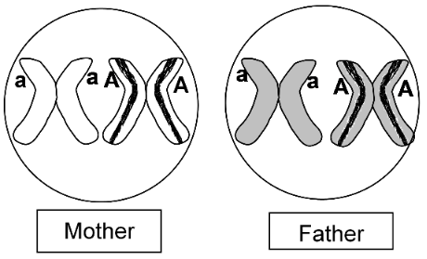
- To prepare the mother’s model chromosomes, use a pair of ah and AH model chromosomes. Tape blank strips of paper to cover the h and H alleles. | 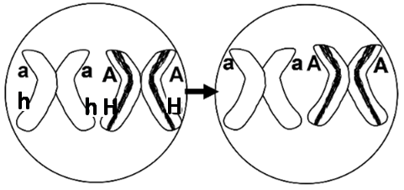
- To prepare the father’s model chromosomes, use a different color pair of the i and I model chromosomes. First, cover the i and I alleles with blank strips of paper. Then, use strips with the a allele or the A allele to finish preparing the father’s model chromosomes. | 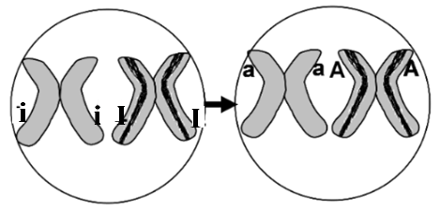
- This chart will guide you as you model meiosis and fertilization. Use chalk, dry erase marker or tape to outline the rectangles of this chart on your lab table. Each white rectangle should be big enough for a model chromosome, and each gray rectangle should be big enough for two.
 |  | Allele in each type of egg produced by meiosis in the mother
 |  | _____ | _____
Allele in each type of sperm produced by meiosis in the father | _____ | ________ | ________ |  | Alleles in the  zygotes  produced by fertilization
 | _____ | ________ | _______ |  | Alleles in the  zygotes  produced by fertilization
- Use one pair of model homologous chromosomes to demonstrate how meiosis produces haploid eggs. Put a model chromosome for each type of egg in the top boxes in your chart on your lab table.
- Use the other color pair of model homologous chromosomes to demonstrate how meiosis produces haploid sperm. Put a model chromosome for each type of sperm in the boxes on the left in your chart on your lab table.

19. Write the allele for each type of egg and sperm in the appropriate white boxes in the above chart.

- Model fertilization by moving the chromosome from one of the eggs and the chromosome from one of the sperm to produce a zygote which will have one chromosome from the egg and one from the sperm.
- Repeat, using each type of sperm to fertilize each type of egg.

20. Write the genetic makeup of each type of zygote in the appropriate gray box in the chart.

21. Use the table below to identify the zygote that would develop into a person with a different phenotype than the parents had. In the chart, circle the genotype of this zygote.

Genotype | → | Protein | → | Phenotype (characteristics)
AA or Aa | → | Enough functional enzyme to make melanin in skin and hair | → | Normal skin and hair color
aa | → | Non-functional enzyme that cannot make melanin | → | Very pale skin and hair color; albino

Biologists use a similar chart to analyze inheritance. This chart is called a Punnett square. |  | A | a
 | A | AA | Aa
 | a | Aa | aa
22. In the Punnett square:
- Write G next to each letter that represents the genetic makeup of a gamete.
- Write Z next to each pair of letters that represent the genetic makeup of a zygote these parents could produce.

To repeat, this Punnett square describes inheritance for two parents who have the Aa genotype. |  | A | a
 | A | AA | Aa
 | a | Aa | aa

23a. Explain why the genotype of each zygote is the genotype of a child these parents could have.

23b. Explain why children often have the same phenotype as their parents.

23c. Explain how a child can have albinism when neither parent has albinism.

Each person has thousands of genes in 23 pairs of homologous chromosomes, so crossing over and independent assortment can produce millions of different combinations of alleles in his/her gametes. If each different type of egg from one mother could be fertilized by each different type of sperm from one father, this would produce zygotes with trillions of different combinations of alleles.

24. Explain why no two siblings inherit exactly the same combination of alleles from their parents (except for identical twins who both developed from the same zygote). A complete answer will include the following terms:
meiosis, genes, alleles, pair of homologous chromosomes, independent assortment,
crossing over, gametes, millions, eggs, sperm, fertilized or fertilization, zygote, trillions.

Sexual vs. Asexual Reproduction
Thus far, we have been discussing sexual reproduction in humans. Asexual reproduction involves only mitosis, without meiosis and fertilization. Asexual reproduction occurs in some types of animals and many types of plants.
This figure shows one type of asexual reproduction. Repeated mitosis produces the cells that form a bud. Then, the bud breaks off to form a new hydra.  25a. Are there any genetic differences between the parent hydra and the new hydra? yes ___ no ___  25b. Explain your reasoning. | 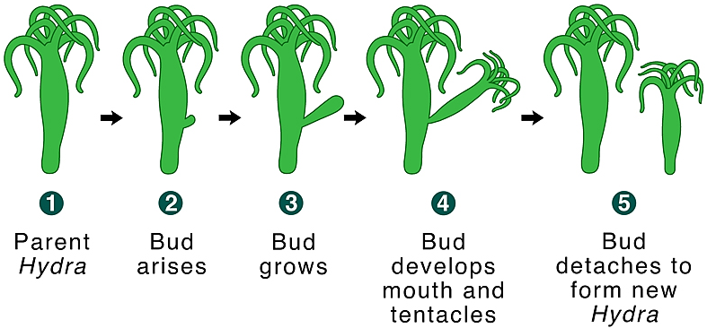  A hydra is an animal that lives in water and uses its tentacles  to catch food.

Another example of asexual reproduction is a clone of genetically identical aspen trees, each sprouting from a shared root system. Over many years, these clones can grow to a very large size. One giant aspen clone contains about 47,000 trees and extends over more than 100 acres.

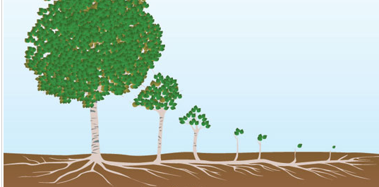

26. Sexual reproduction involves ___ parent(s) and produces genetically ______________ offspring.
(0/1/2) (diverse/identical)
Asexual reproduction involves ___ parent(s) and produces genetically ________________ offspring.
(0/1/2) (diverse/identical)

27a. What would be the advantage of asexual reproduction for an organism that lives in a stable environment that does not change?

27b. What would be the advantage of sexual reproduction for an organism that grows in a variable environment that often changes?

by Drs. Ingrid Waldron, Jennifer Doherty, R. Scott Poethig, and Lori Spindler, Department of Biology, University of Pennsylvania, © 2025; Word files for this Student Handout and Teacher Preparation Notes with background information and instructional suggestions are available at https://serendipstudio.org/sci_edu/waldron/#meiosis .

